
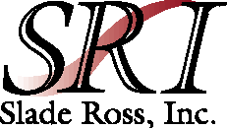


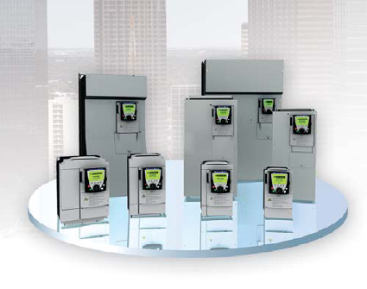
Square D Variable Frequency Drive Training and Certification

Sponsored by: Square D and Slade Ross, Inc

Date: Thursday April 12, 2007

Time: 8:30 a.m. until 4:00 p.m.

Place: 1711 W. Platt Street, Tampa Florida 33606

Telephone: (813) 250-0488

Class Conducted by: Olin G. Bundy Organizational Development Specialist for Schneider Electric

Training will include:
- Basic drive theory
- Square D product overview
- Hands on Lab for all Square D Altivar Drives

Each participant will receive programming software, user manuals, and Bluetooth ™
instructions as well as Factory certification to perform start up and warranty troubleshooting.

Names of Attendees (for Certificates)

___________________________________ ______________________________

___________________________________ _______________________________

___________________________________ _______________________________

