SRI Logo lower half only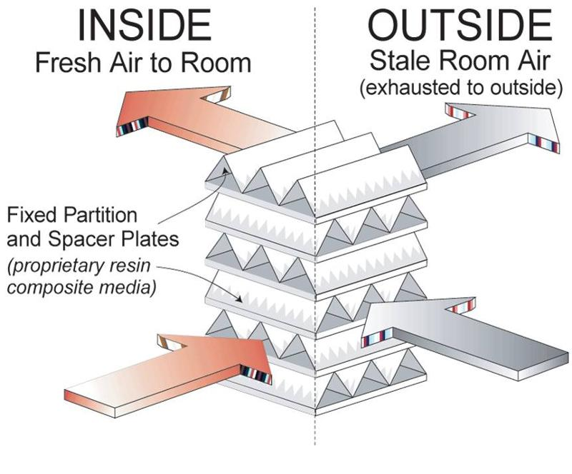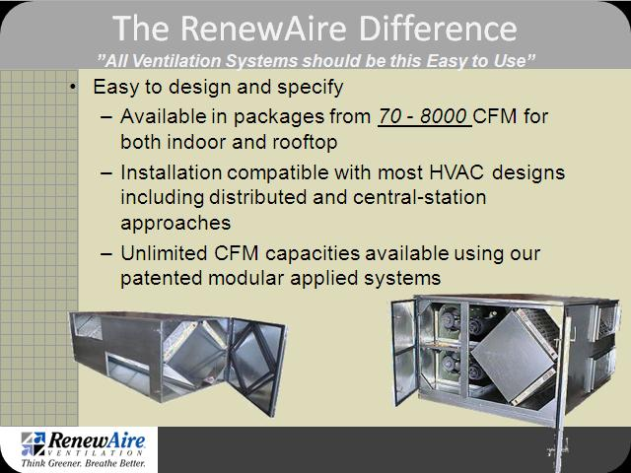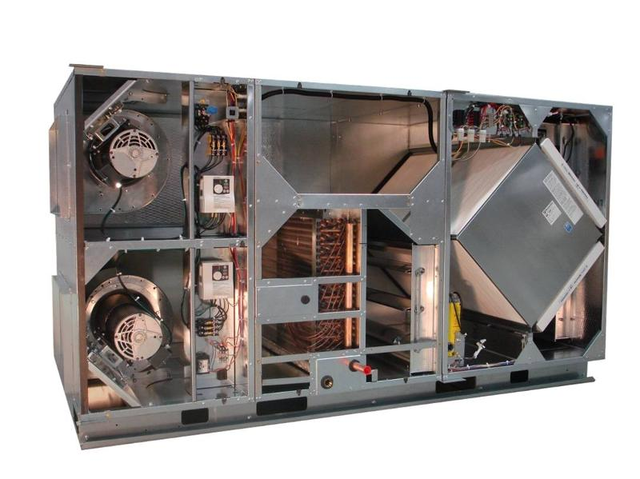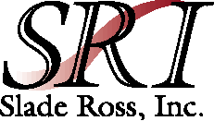

RenewAire is:

* Static-Plate Core Technology
* UL labeled and listed with full ARI certification and qualifies for rebates
* Maintenance performed by janitorial staff
* Available in both Fan Powered and Stand alone modules
* Available in indoor or outdoor configurations

**NEW PRODUCT ANNOUNCEMENT- HEAT RECOVERY CORES**

***We are proud to announce representation of RenewAire, Inc in the Florida West Coast Market***

**Our graduate engineers and systems experts are available for a presentation. Please call or respond to this e-mail and we will set up an appointment**

The RenewAire Core

* Positive Air Stream Separation
* Transfers both sensible and latent energy
* Certified 0% Cross Contamination
* Laminar Flow, Doesn't Clog
* Low Static Pressure - saves fan horsepower
* Suitable for bathroom exhaust
* 10 year core warranty
* Available as DOAS unit as shown
* As stand alone cores
* With mixed airstreams

**223 South Rome Ave.**

### Tampa, FL. 33606

**(Ph) 813-250-0488**

**(Fax) 813-250-0128**

**e-mail: Bill Slade** [**wslade@sladerossinc.com**](mailto:wslade@sladerossinc.com)

**Jeff Ross** [**jross@sladerossinc.com**](mailto:jross@sladerossinc.com)

**Tim Hart** [**thart@sladerossinc.com**](mailto:thart@sladerossinc.com)

## Joe Cox [jcox@sladerossinc.com](mailto:jcox@sladerossinc.com)

**Stephanie Franklin** [**sfranklin@sladerossinc.com**](mailto:sfranklin@sladerossinc.com)

**Web Site** [**www.SladeRossInc.com**](http://www.SladeRossInc.com)